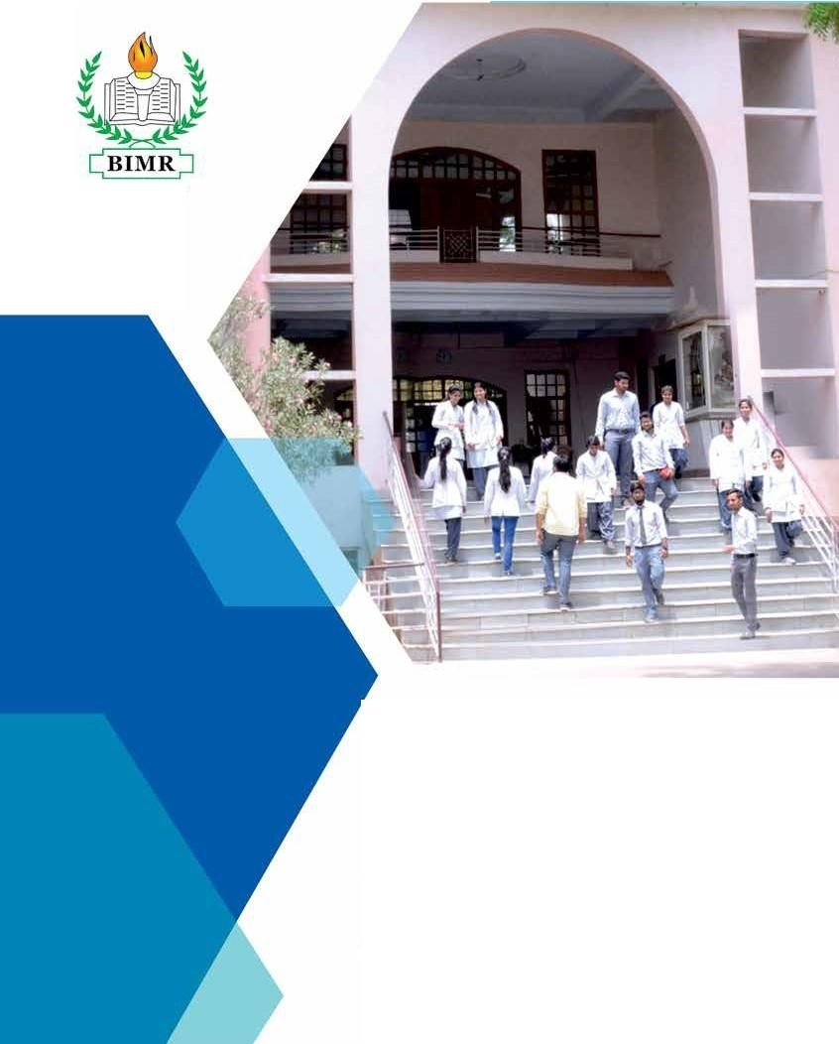

Since 1983

PROSPECTUS

BIMR COLLEGE OF PROFESSIONAL STUDIES
Run by Birla Nagar Jana Seva Trust

Founder Chairman

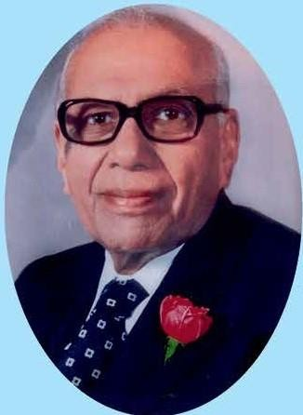
Syt. D.P. Mandelia
(1907-2005)
Founder and Chairrman

Syt. D. P. Mandella Ji had been the Founder Trustee and Chairman of the Trust-Birla Nagar Jana Seva Trust since Its inception. He steered the institute to the present summit.
He, at the age of 96 years, relinquished his office on 29th December 2003. On the request of the trustees of Birla Institute of Medical Research h, e had consented to continue as "Chairm,u, Emeritus". He continued to shower his valuable and benevolent advice on the college and remained a guiding force till his soul departed on heavenly abode on, 30th May 2005.

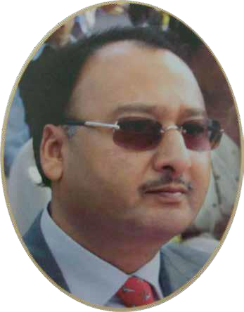
Chairman’s Message

At BIMR College of Professional Studies, excellence in whatever we do is our hallmark.
With the blessings of Goddess Saraswati, in this temple of infinite knowledge and center of education, our dedicated faculty and the administrative team works tirelessly in pursuit of enhancing the level
of competence and modernizing the techniques of imparting education. This has brought all round appreciation and acknowledgment of the institute.
I wish all students success in conquering their goals in life and bring glory to the institute.

Shri B. G. MANDELIA
Chairman

3

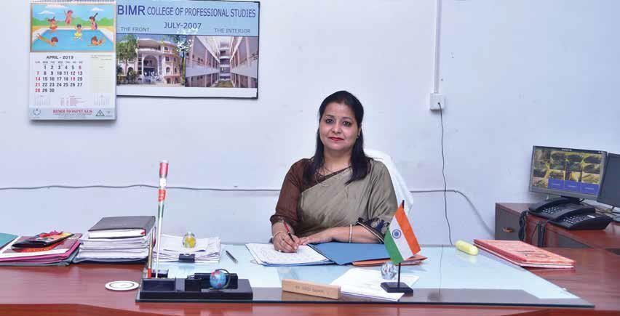

Principal’s Message
It is my immense pleasure to apprise you that BIMR College of Professional Studies (formerly known as BIMR College of Life Sciences) has completed twenty years glorious of its establishment and has achieved academic excellence.
Birla Nagar Jana Seva Trust has undertaken the viable initiative and established the college of the sciences with the effect from August 1998. Initially undergraduate courses were stated with industrial microbiology and biotechnology as one of the subjects pursuing the prime objective and vision of preparing the youth with regard to futuristic endeavours and ensure employment prospects. Emphasis was laid on quality
education, discipline and inculcating moral ethical values that are inevitably paramount attributes to face the challenges of life.
Further to glorify and augment academic pursuits-four year Bachelor of Physiotherapy Course was started during 2003-2004. After its successful establishments. We took the lead as the forerunner institute to commence MPT course in Gwalior-Chambal region in 2008-2009. The college is affiliated to Madhya Pradesh Medical Science University, Jabalpur and recognized by MP Para Medical Council, Bhopal.
It has marked a niche for itself as a result of industrious efforts of academic and administrative staff. Faculty is the backbone of the Institute and they strive hard to provide quality education and training to mould students as excellent and worthy citizens of the country. As the journey of thousand miles begins with single step, one can take a leap forward to attain greater heights.
Come; feel proud to be the part of our institution and install with the credentials of academic excellence,
distinction and perfection.

(Dr. Shilpi Kapoor)
Principal

4

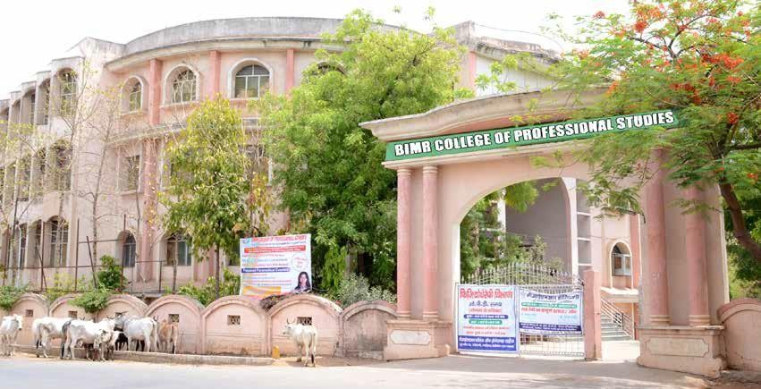

5


Courses Offered

- B.P.T (4 yrs. 6 months degree course)
- M.P.T. (Ortho, Neuro) 2 yrs. Post Graduate degree course
- BMLT (Bachelor of Medical Laboratory Technician) (3 yrs. degree course)
- DMLT (2 yrs. Diploma course)
- CT/MRI Technician (1 yr. Certificate course)
- Operation Theatre Technician (1 yr. certificate course)

6

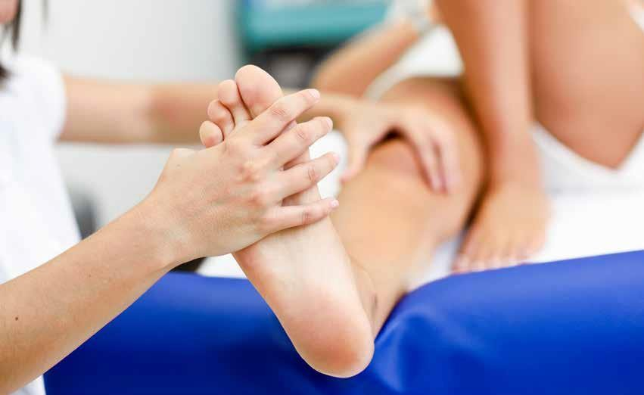
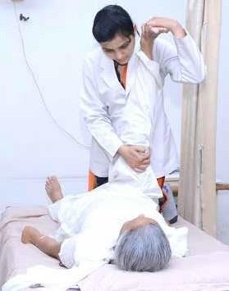
Department of Physiotherapy

The Bachelor of Physiotherapy (B.P.T.) programme is 4½ years duration including internship with an intake of 50 students annually.
Eligibility: 12th with Biology (50%).
Master’s Programme (M.P.T.) with Ortho, Neuro with an intake of 5 seats in each discipline annually.
Eligibility : B.P.T. with 50%.

What is Physiotherapy
It is an autonomous profession of scientific medicine, where the physical ailments are treated with heat, cold, electric currents which eventually renders a patient functionally independent. The art of treating these physical ailments is called as Physiotherapy/Physical Therapy and the one, who treats is termed as Physical Therapist/

7

Physiotherapist and so popularly known as a Physio. A registered Physio can assess, diagnose, prescribe and treat patients on an individual basis, as well as to refer a patient to other health professionals if in need.

Who Needs Physiotherapy
Right from a Neonate in ICU till a bed-ridden old geriatric,
everyone needs a Physio-Sounds New? Yes it is.
The concept that Physios are needed on the sports grounds has changed ever since multi speciality hospitals and super- specialization has come into trend.
Today, all the super-specialty hospitals have a Specialized Physiotherapy department in all the branches such as Neuro-
rehab, Orthopedics, Pediatrics, Cardio-pulmonary rehab, as well as a Gynecology department.
Research has broadened the scope of Super-specialization with Doctoral Programme in Physiotherapy offering wide areas of Clinical Research.

Scope of Physio Therapy
- Hospitals
- Rehabilitation Centers
- Community Health Care Centers
- Fitness Centers
- Health Clubs
- Sports Centers

- Special School
- Vocational Rehab Centers
- Senior Citizen Centers
- Out Patient Clinics etc.
[Thus, as life style of individuals in changing it’s absolutely sure that pt offers bright future in the coming years.]

B.P.T. Papers

I Year
- Human Anatomy

- Human Physiology
- Bioelectrical Modalities
- Sociology & Psychology

Year
- Microbiology & Pathology
- Biochemistry & Pharmacology
- General Medicine
- Orthopedics (Clinical Orthopedics)
- General Surgery, OBG, ENT, Ophthalmology

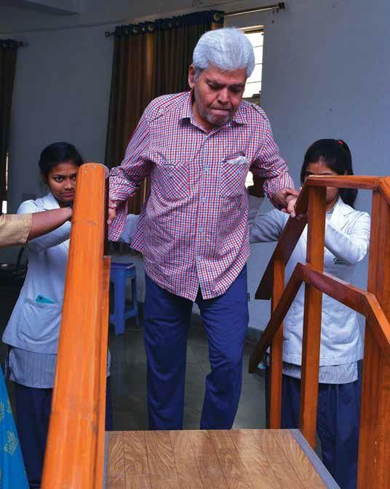

8

- Exercise Therapy including Yoga
- Electro-therapy

Year
- PT in Orthopaedics
- PT in Neurology
- Biomechanics & Bioengineering
- Cardiothoracic Diseases & Surgery and Neurology & Neurosurgery
- Physical Evaluation

IVYear
- Physical diagnosis and Exercise prescription
- Physiotherapy in sports
- Physiotherapy in Cardiothoracic conditions
- Rehabilitation & Biostatistics
- PT Ethics / Community Medicine
This is followed by 6 months internship.

M.P.T. Papers

1st Year
- Basic Medical Sciences.
- Biomechanics and Kinesiology.
- Exercise Therapy and Emergency Care.
- Exercise Physiology.

2nd Year
- Physical Medicine and Rehabilitation (Common to all) Theory
- PT in elective surgery
- PT in elective Surgery
- Psychology
- Dissertation

Facilities available by the Physiotherapy Department
Exercise Therapy facilities
- Shoulder Wheel
- Rowing Machine
- Static Cycle
- Quadriceps Chair
- Reciprocal Exerciser
- Weight Cuffs
- Swiss Ball
- Gait Training
- Postural Mirror
- Overhead pulley
- Suspension Frame
- Wooble Board
- Rocker Board
- Wrist Exerciser
- Finger Exerciser
- Reflex balls
- Treadmill
- Tubings

Electro therapy facilities
- Laser Therapy
- UVR Therapy
- Ultrasonic Therapy
- Sport Wave diathermy
- TENS
- Electronic Simulator
- Galvanic
- Faradic
- Hydro Therapy
- Hydro Collateral Packs
- Cold Packs
- Traction
- IRR
- Continuous Passive motion
- lontophoresis
- Pelvic floor stimulator

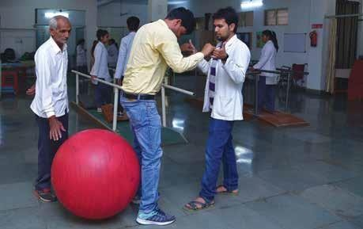

9

Scheme of Examination : Bachelor of Physiotherapy (B.P.Th.)

First Year B.P.Th. Examination

S.No. | Subject | Internal Assessment |  | University Examination |  |  | Total
S.No. | Subject | Theory | Practical | Theory | Viva | Practical | Total
1 | Human Anatomy | 20 | 20 | 100 | 20 | 40 | 200
2 | Human Physiology | 20 | 20 | 100 | 20 | 40 | 200
3 | Fundamental of Physics, Biomechanics & Biomechanical Modalities | 20 | 20 | 100 | 20 | 40 | 100
4 | Fundamental of Medical Electronics & Principles of Bioelectrical Modalities | 20 | 20 | 100 | 20 | 40 | 200
5 | Psychology & Sociology | 20 | -- | 80 | -- | -- | 100
Total Max. Marks |  |  |  |  |  |  | 900
N.B.- Viva marks will be added in theory marks along with internal assessment theory, candidate have to get min. 50% marks in theory and viva collectively for passing the examination.

Second Year B.P.Th. Examination

S.No. | Subject | Internal Assessment |  | University Examination |  |  | Total
S.No. | Subject | Theory | Practical | Theory | Viva | Practical | Total
1 | Pathology & Microbiology | 20 | -- | 80 | -- | -- | 100
2 | Biochemistry & Pharmacology | 20 | -- | 80 | -- | -- | 100
3 | Medicine including Pediatrics & Geriatrics | 20 | -- | 80 | -- | -- | 100
4 | General Surgery, Obstetrics & Gynecology | 20 | -- | 80 | -- | -- | 100
5 | Exercise therapy including yoga | 20 | 20 | 100 | 20 | 40 | 200
 |  | 20 | 20 | 100 | 20 | 40 | 200
Total Max. Marks |  |  |  |  |  |  | 800
N.B.- Viva marks will be added in theory marks along with internal assessment theory, candidate have to get min. 50% marks in theory and viva collectively for passing the examination.

10

Third Year B.P.Th. Examination

S.No. | Subject | Internal Assessment |  | University Examination |  |  | Total
S.No. | Subject | Theory | Practical | Theory | Viva | Practical | Total
1 | Neurology including Psychiatry & Neurosurgery | 20 | -- | 80 | -- | -- | 100
2 | Orthopedics | 20 | -- | 80 | -- | -- | 100
3 | Applied Biomechanics & Kinesiology | 20 | -- | 80 | -- | -- | 100
4 | Physiotherapeutic in Neurology & Neurosurgery | 20 | 20 | 100 | 20 | 40 | 200
5 | Physiotherapeutic in Orthopedic Conditions | 20 | 20 | 100 | 20 | 40 | 200
6 | Physical Evaluation, Diagnosis & Prescription | 20 | 20 | 100 | 20 | 40 | 200
Total Max. Marks |  |  |  |  |  |  | 900
N.B.- Viva marks will be added in theory marks along with internal assessment theory, candidate have to get min. 50% marks in theory and viva collectively for passing the examination.

Fourth Year B.P.Th. Examination

S.No. | Subject | Internal Assessment |  | University Examination |  |  | Total
S.No. | Subject | Theory | Practical | Theory | Viva | Practical | Total
1 | Community PT, Rehabilitation & Disability prevention | 20 | -- | 80 | -- | -- | 100
2 | Research methodology & Biostatics | 20 | -- | 80 | -- | -- | 100
3 | Cardiothoracic diseases and surgeries | 20 | -- | 80 | -- | -- | 100
4 | Physiotherapeutic in General & Cardiothoracic Conditions | 20 | 20 | 100 | 20 | 40 | 200
5 | Sports Physiotherapy | 20 | 20 | 100 | 20 | 40 | 200
6 | PT Ethics, management & Administration ** NUES | -- | 100 | -- | -- | -- | 100
7 | Project Work ** NUES | -- | 100 | -- | -- | -- | 100
Total Max. Marks |  |  |  |  |  |  | 900
N.B.- Viva marks will be added in theory marks along with internal assessment theory, candidate have to get min. 50% marks in theory and viva collectively for passing the examination.
** NUES = Non-university Examination Subject

11

MPT 1st Year (Common for all candidates)
Institutional Examination as per University Notification

S.No. | Subject | Max. Marks | Minimum Pass Marks
1 | Basic Medical Sciences & Principles of Physiotherapy Practice | 100 | 50
2 | Biomechanics & Kinesiology | 100 | 50
3 | Research Methodology & Biostatics and Educational Methodology | 100 | 50

MPT 2nd / Final Year University Examination

S.No. | Subject | Written | Practical | Viva | Total
1 | Exercise Physiology & Nutrition | 100 | -- | -- | 100
2 | Physical Diagnosis & Rehabilitation | 100 | -- | -- | 100
3 | Elective-I* | 100 | 100 | 50 | 250
4 | Elective-II** (Advanced Physiotherapeutic) | 100 | -- | -- | 100
5 | Dissertation | -- | -- | 50 | 50
 |  |  |  |  | 600

* Elective-I Subjects
MPT Sports : Sprots Physiotherapy
MPT Orthopedics : Orthopedic PhysiotherapyMPT Neurology : Neurologic Physiotherapy
MPT Cardiothoracic : Cardiopulmonary Physiotherapy
MPT Obstetrics & Gynecology : Physiotherapy in Obs. & Gynecological conditions

** Elective-II Subjects (Advanced Physiotherapeutic)
MPT Sports : Advanced Physiotherapeutic in Sprots Physiotherapy
MPT Orthopedics : Advanced Physiotherapeutic Orthopedic Physiotherapy MPT Neurology : Advanced Physiotherapeutic Neurologic Physiotherapy
MPT Cardiothoracic : Advanced Physiotherapeutic Cardiopulmonary Physiotherapy
MPT Obstetrics & Gynecology : Advanced Physiotherapeutic Physiotherapy in Obs. & Gynecological conditions

12


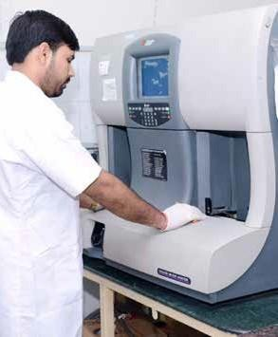
Department of Pathology

BMLT ( 3 yrs. Degree course):
Eligibility: 10+2 or its equivalent with science subject (Physics, Chemistry, and Biology) with minimum 50% marks.
B.M.L.T (Bachelor in Medical Laboratory Technology) is one of the largest and impoverished wings in the modern healthcare field. With the advancement of medical science, the physician requires the help of medical laboratories for the treatment of rapidly growing diseases in the needs of skilled persons / employees.
B.M.L.T is a graduate medical lab technologist program, the B.M.L.T course is of 3 years, and it is a career oriented course.
B.M.L.T Scope /Career /Jobs in B.M.L.T: Medical technologists are an integral part of the medical profession. These professionals are involved in the practical and technical work for proper diagnosis

13

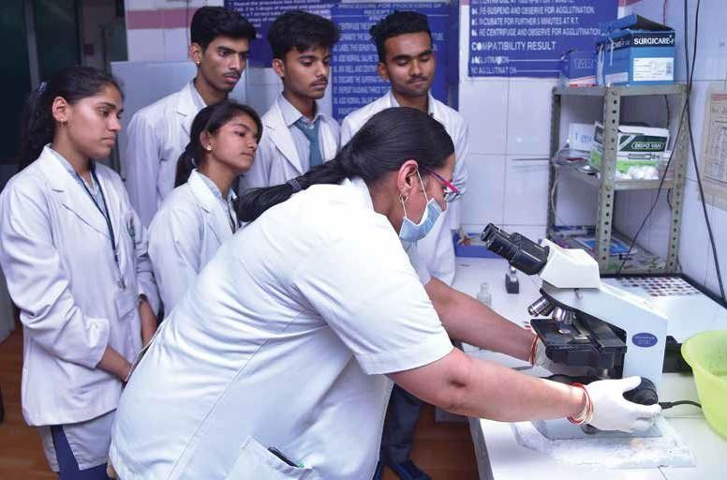
and effective functioning of biochemical laboratories. Career prospects in this field depend on the educational and technical skills of the technologist. With the development in the private sector, these days there are so many private hospitals, nursing homes, blood banks, pathology laboratories etc. Demand
for laboratory technologist is on the up-swing, they can also work as lab manager /
consultant / supervisor, health care administrator, hospital outreach coordination, laboratory information system analyst
/ consultant, educational consultant / coordinator etc.

14
DMLT (Diploma in Medical Laboratory Technology):
Eligibility: 10+2 or its equivalent with science subject (Physics, Chemistry, and Biology) with minimum 45% marks.
Diploma in Medical Laboratory Technology (DMLT) is a Medical Lab Technologist Diploma course.
Medical laboratory technology is the branch of medical science responsible for performing
laboratory investigations relating to the diagnosis, treatment, and prevention of disease. Within completion of two years of the above given course, the candidate after undergoing requisite course
module and University exam, diploma will be awarded. The course is career orienting and job providing in nature along with many further study scopes.

Scope of Diploma in Medical Laboratory Technology (DMLT) Course
The students are skilled to perform tests that aid in the diagnosis and treatment of diseases as the program equips candidates with the necessary skills required to handle lab equipment and perform accurate pathological tests. After passing the course candidates can assist

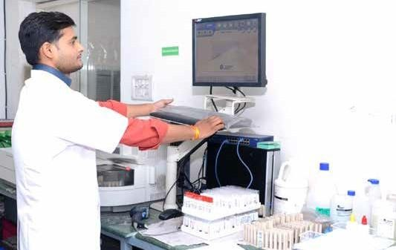
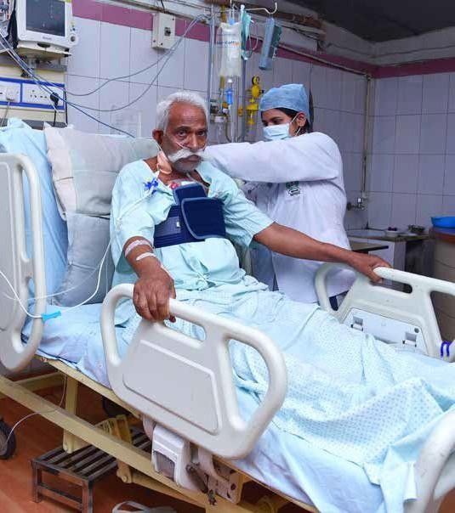
the doctors in taking samples, centrifuging, making slides, using specified stains etc, under proper guidance.
They have also many scopes available in molecular diagnostics, molecular biotechnology companies and in vitro fertilization laboratories as well as in research labs.
They can also assume administrative functions such as reporting and recording results of tests conducted in the laboratory, maintaining accurate clinical records, selecting and evaluating laboratory equipment and new test methodologies and performing other duties as may be assigned by the laboratory supervisor.

Diploma in Medical Laboratory Technology (DMLT) Employment Areas :
  - Government Medical Colleges
  - Pathology l Labs
  - Government Hospitals
  - Military Services
  - Diploma in Medical Laboratory Technology (DMLT) Job Types
  - Laboratory Assist. Manager
  - Consultant & Assist. Supervisor
  - Health Care Administrator
  - Hospital Outreach Assist. Coordinator

15

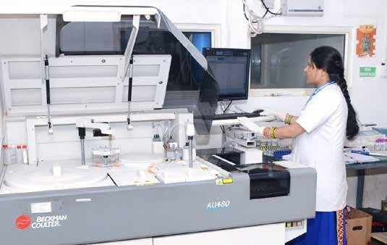
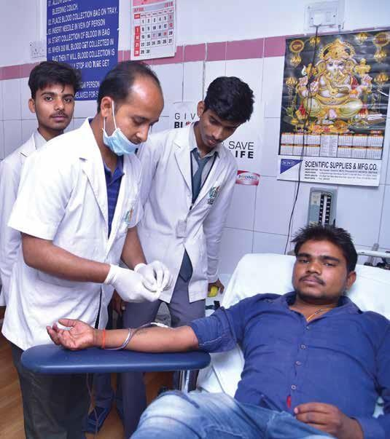
    - Laboratory Information System Analyst
    - Educational Assist Consultant
    - Teacher
DMLT Diploma programs are available for those looking to fulfil the requirements for
becoming lab technicians. A lab technician diploma program is 2 yrs and focus on one core set of skills used in the laboratory. DMLT is the application of laboratory techniques to find
out the cause of disease. Clinical laboratory testing is regarded
as one of the several important sources of clinical data essential for diagnosis, prognosis and treatment of disease. A clinical laboratory medicine involves all aspects of medicines ranging from the field of biochemistry, microbiology, hematology, immunology, clinical microscopy, biophysics, histopathology and cytology.

Medium of instruction and examination:
In case of diploma courses the medium of instruction will be bilingual (English or Hindi) and the medium of examination will be either English or Hindi as per the convenience of the student.

O.T. Technician
Eligibility : 10+2 , biology with 45%.
OT Technicians work in Operation Theatre of hospitals, Emergency Departments and Intensive Care

16

Units. Their main responsibility is to assist and help Doctors and Surgeons during surgery and emergency procedures. Under the setup of a doctor’s facility, Operation Theatre experts are generally part of a team that comprises of Doctors, nurses and other allied healthcare service professionals.

CT/MRI Technician :
Eligibility : 10+2, biology with 45%.
Since this is a certificate course, after completion of the course, one may land entry level technician’s post at diagnostic labs, medical imaging labs,
radiography centers and hospitals or clinics offering MRI scanning service. Main tasks of an MRI technician include-
  - Preparing the patient for the scan
  - Providing instructions to the patient
  - Setting up the MRI scanner
  - Adjusting the MRI scanner parameters
  - Positioning the patient for the scan
  - Operate the scanner (handle the controls and/or software)
  - Record the scanned images and results
  - Follow necessary safety precautions and directions
MRI technicians usually work under the guidance of qualified
Doctors. They follow instructions provided by the Doctor, operate the scanner, record the images and hand over the record to the Doctor (for diagnosis).

JOB/WORK areas:
X-Ray technician, Assistant X- Ray technician etc and alike in hospitals, clinics, medical labs, out-patient care centers etc.

ACADEMIC CALENDER
- Academic session begins from 1st September as per guidelines of MP Paramedical Council, Bhopal
- Orientation Program for new students on 15th September

Note:
  - Regular seminars (academic and motivational will be conducted throughout the year.
  - For B.P.T., M.P.T., B.M.L.T. and D.M.L.T. students the internals, class test and pre
university examination will be held as per schedule.

17

Bachelor in Medical Lab Technology (BMLT)
First Year BMLT Examination

S.No. | Subject | Theory | Internal Assessment | Practical | Total
1 | Basic Histology (Anatomy & Physiology) | 100 | 100 | 100 | 300
2 | Microbiology-I | 100 | 100 | 100 | 300
3 | Biochemistry-I | 100 | 100 | 100 | 300
4 | Hematology-I | 100 | 100 | 100 | 300
Total Max. Marks |  |  |  |  | 1200
N.B.- Internal Assessment marks will be added in theory marks, candidate have to get min. 50% marks i.e. - 100 marks in theory and internal assessment collectively for pssing the examination and in practical he/she should get 50% marks i.e.- 50 marks to get pass.

Second Year BMLT Examination

S.No. | Subject | Theory | Internal Assessment | Practical | Total
1 | Basic Histology (Anatomy & Physiology) | 100 | 100 | 100 | 300
2 | Microbiology-II | 100 | 100 | 100 | 300
3 | Biochemistry-II | 100 | 100 | 100 | 300
4 | Hematology-II | 100 | 100 | 100 | 300
Total Max. Marks |  |  |  |  | 1200
N.B.- Internal Assessment marks will be added in theory marks, candidate have to get min. 50% marks i.e. - 100 marks in theory and internal assessment collectively for pssing the examination and in practical he/she should get 50% marks i.e.- 50 marks to get pass.

First Year BMLT Examination

S.No. | Subject | Theory | Internal Assessment | Practical | Total
1 | Basic Histology (Anatomy & Physiology) | 100 | 100 | 100 | 300
2 | Microbiology-III | 100 | 100 | 100 | 300
3 | Biochemistry-III | 100 | 100 | 100 | 300
4 | Hematology-III | 100 | 100 | 100 | 300
Total |  |  |  |  | 1200
5 | Instrumentation # | -- | 50 | -- | 50
Total Max. Marks |  |  |  |  | 1250
N.B.- Internal Assessment marks will be added in theory marks, candidate have to get min. 50% marks i.e. - 100 marks in theory and internal assessment collectively for pssing the examination and in practical he/she should get 50% marks i.e.- 50 marks to get pass.

18

Diploma in Medical Lab Technician (DMLT)
First Year DMLT Examination

S.No. | Paper | Subject | Max. Marks | Min. Passing Marks
1 | Paper-I | Human Anatomy & Physiology | 100 | 50
2 | Paper-II | Biochemistry | 100 | 50
3 | Paper-III | pathology-I : Hematology & Blood Banking,Clinical Pathology & Parasitology | 100 | 50
4 | Paper-IV | Pathology-II : Microbiology & Serology Histology & Cytology | 100 | 50
There shall be Institutional /College level theory examination as per university notification, marks to be send to University for internal assessment purpose of university examination)

Second Year DMLT Examination
There shall be university examination at the end of 2nd year curriculum of Diploma in Medical Lab Technician (DMLT)

S.No. | Paper | Subject | Theory | Internal Assessment | Practical | Total
1 | Paper-I | Human Anatomy & Physiology | 100 | 100 | 100 | 300
2 | Paper-II | Biochemistry | 100 | 100 | 100 | 300
3 | Paper-III | pathology-I : Hematology & Blood Banking, Clinical Pathology & Parasitology | 100 | 100 | 100 | 300
4 | Paper-IV | Pathology-II : Microbiology & Serology Histology & Cytology | 100 | 100 | 100 | 300
Total Max. Marks |  |  |  |  |  | 1200
N.B.- 1. First year institutional/college level theory examination’s awarded marks would be consider as Internal assessment marks and candidate have to get min. 50% marks in university theory examination in addition to Internal assessment marks i.e. 100 marks collectively for passing the examination.
2. University Practical examination of 100 marks is inclusive of viva and candidate should get separate 50% marks i.e. 50 marks to get pass.

19

20

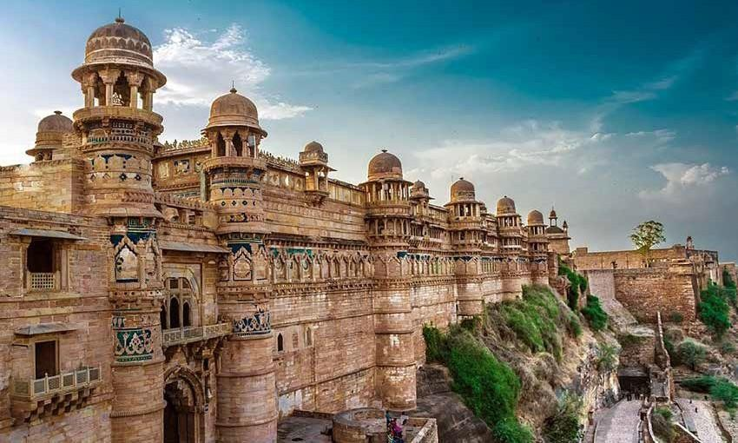
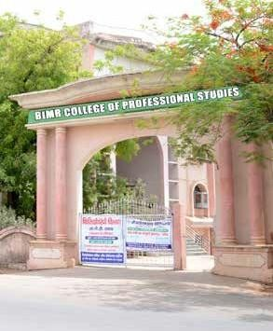
Around Us

Gwalior is recognized as a magnificent tourist place of the state of Madya Pradesh. Madhya Pradesh, as the very name suggests, is the heart of India, surrounded by seven states of the country. The Gwalior is located 319 kilometers (198 mi) south of Delhi, the capital city of India, The city comprises of exquisite natural bounties with majestic historical monuments that are witness to immensely glorious history and culture. The state possesses unending ranges of undulating mountains, deep forests and also rivers that are held in great esteem and sanctity.
Gwalior is the crowning glory of the state where the most celebrated Gwalior Fort stands out in full grandeur and splendor as a symbol of this vast growing city. The city depicts spontaneous fusion of Art, Culture and Music.

21

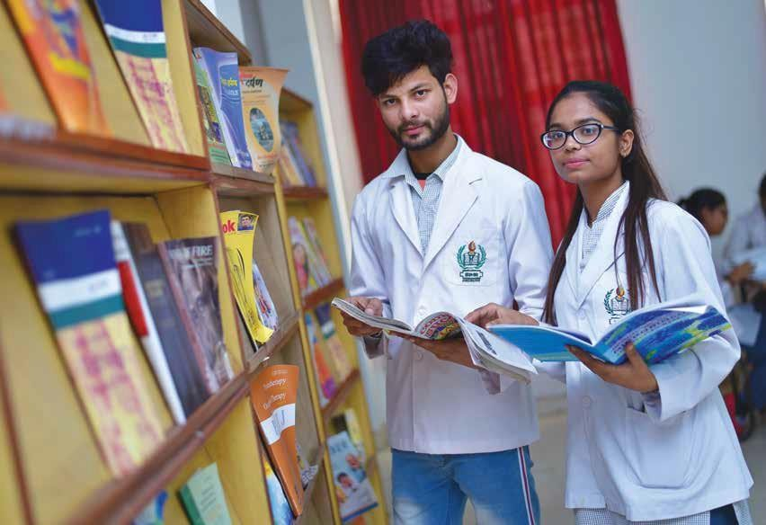
The city is now developing with incessant pace into a large industrial complex besides being a center of ever
expending spectrum of distinctive education.
BIMR is one such Landmark institution providing education in Physiotherapy and Paramedical courses, imparted with perfection and veracity.

LIVING ON CAMPUS
“BIMR College of Professional

22
Studies” is situated near Residency, Morar, Gwalior. The college possesses sprawling lawns in an elegant surrounding coupled with the splashes
of greenery, away from the commotions of the city and yet close to it. The college is
presently in the compact building with large size airy class rooms, well equipped laboratories for practical besides a large size computer laboratory.

LIBRARY
It is the fastest growing academic resource. It offers a vast collection of books on all applied subjects. It subscribes a number of journals and periodicals. The most attractive is internet access facility - a large collection of CDs on variety of tutorials. A good number of technical magazines on the applied subjects and all the major newspapers form an integral part of library. Book
bank facility is available to all PG
students.

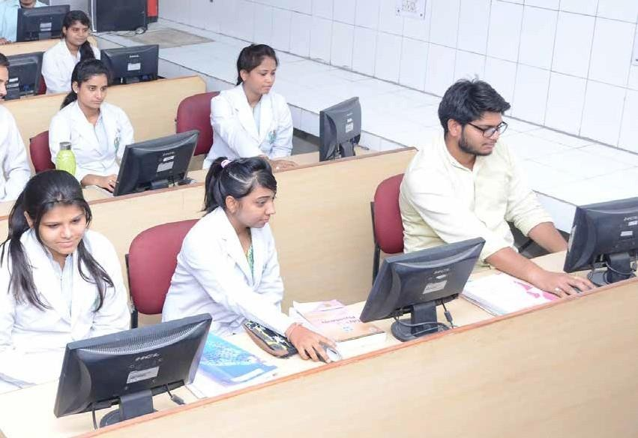
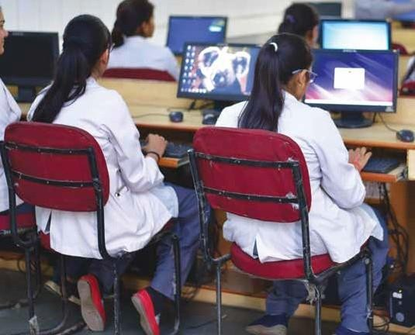

INTERNET
It is available to all students through college computer centers. Students can access it to keep themselves updated with the current global knowledge and for their students and their research project etc. as well as
e-mailing.

OFF CAMPUS ACCOMMODATION
Though we wish that at least in the first year, every outstation

23

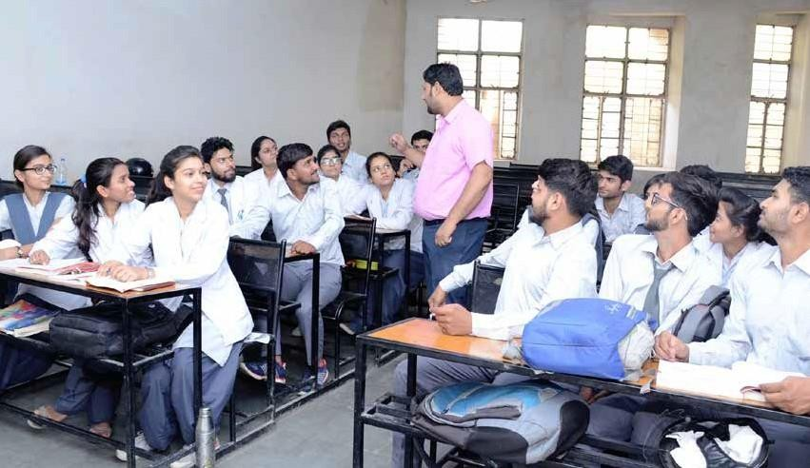
student be accommodated in the campus hostels but being limited, some choose to stay off- campus in private hostel. Rented accommodation, an apartment, townhouse, villa or house. There are many affordable options
in the suburb around college hostels and new students often arrange to share accommodation during their stay in the college.

Institutional Services

HEALTH SERVICES
There is also provision for student’s sick room in the BIMR Hospital.

ACCESSIBILTY
BIMR College of Professional Student is well connected and easily accessible from Railway Station and Bus Stand being

24

hardly 6 Km. away. The college is also well connected from the main city and other markets.
Conveyance is also easily available.

CAMPUS AMENITIES
The Campus is a self-sufficient enclave with well-lit roads, a canteen, parking, standby power generators in the college.

BANK
Allahabad Bank is functional walking distance the campus.

BIMR HOSPITAL
The BIMR HOSPITAL is a 300
bedded multi-super-specialty hospital. The hospital is having cardiology, Cardiothoracic surgical unit (with facilities of Angiography, Pacemaker, Echo

Cardio Thoracic Surgery i.e. Coronary Bypass surgery, Single, Double Valve Replacement Surgery, Plastic surgery
apart from various specialty department such as Surgery, Medicine, Pediatric, Gynecology, Eye, ENT, Dental, Urology etc.
Hospital have fully equipped NABL Accredited Pathology Lab. State of art ultra-modern intensive care units which includes ICCU, ICU, NICU, Post- Operative Surgical ICU, DPM Neuro ICU & Neuro Surgery Centre including a burn unit, we have total of 100 beds
for critical care. The hospital has well attended outpatient department and well looked after in-door having continuous
oxygen supply and air cooling/air

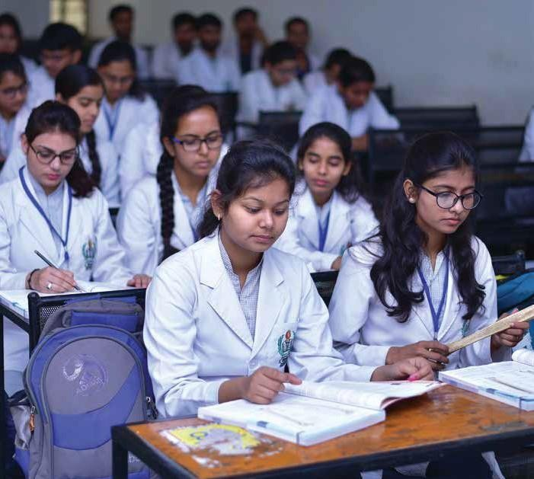
conditioning system. The hospital has facility for Cancer Treatment, Radiotherapy with Linear Accelerator, Cancer surgery
and chemotherapy. Patients and attendants coming from out station are being provided accommodation on demand, if required.

SPORTS
College has facilities for indoor and outdoor games. Sports
kits are available in sufficient quantities. Playground for outdoor games like Cricket, Hockey, Badminton, Football etc. are available in the college campus. A full time service of Sports Officer is available for guidance in sports activities.

SAFETY IN THE CAMPUS
Adequate security staff is available and safety measures are followed everywhere on the campus to ensure the welfare
staff and students alike. Fire extinguishers are available at every probable location on the campus.

RAGGING
Ragging is strictly prohibited in the college as well as in the hostel. If any student found indulging in such type of
activities, necessary action will be taken.

25

Fee Structure

S. No. | Fee | Tuition Fee | Caution Money (refundable) | Uniform | Total
1 | B.P.T. | 50000 | 3000 | 3000 | 56000
2 | M.P.T. | 100000 | 3000 | 3000 | 106000
3 | B.M.L.T. | 45000 | 3000 | 3000 | 51000
4 | D.M.L.T. | 36000 | 3000 | 3000 | 42000
5 | O.T. Technician | 25000 | 3000 | 3000 | 31000
6 | C.T. /M.R.I. | 25000 | 3000 | 3000 | 31000
7 | D.X.R.T | 36000 | 3000 | 3000 | 42000

Note:
- Enrolment fee, eligibility fee and exam fee will be borne by the student as decided by The MP Medical Science University, Jabalpur through online.
- EX- Students Practical Exam. Fee Rs. 5000/-, Applicable to all Physiotherapy Students.

28


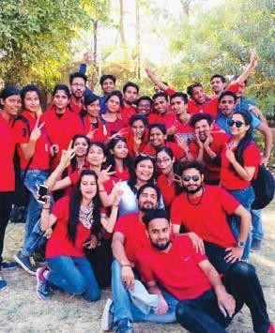
Cultural Activities

Writeup of cultural activities for this page is required Writeup of cultural activities for this page is required Writeup of cultural activities for this page is required Writeup of cultural activities for this page is required Writeup of cultural activities for this page is required Writeup of cultural activities for this page is required Writeup of cultural activities for this page is required Writeup of cultural activities for this page is required Writeup of cultural activities for this page is required Writeup of cultural activities for this page is required Writeup of cultural activities for this page is required Writeup of cultural activities for this page is required Writeup of cultural activities for this page is required Writeup of cultural activities for this page is required Writeup of cultural activities for this page is required Writeup of cultural activities for this page is required Writeup of cultural activities for this page is required Writeup of cultural activities for this page is required

29

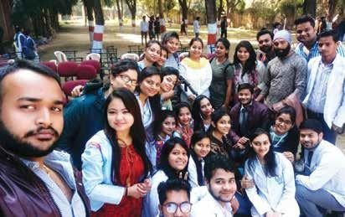
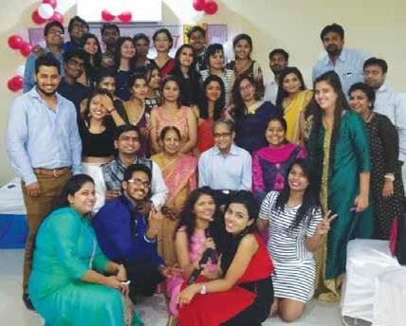
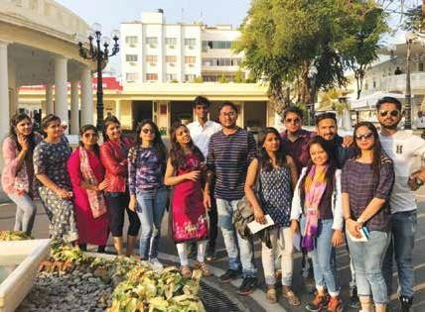
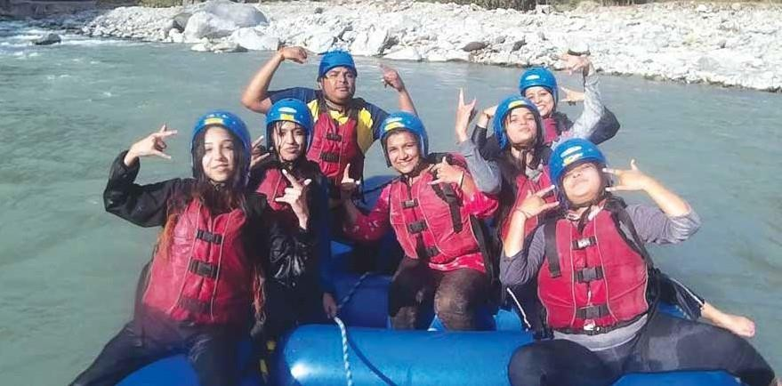
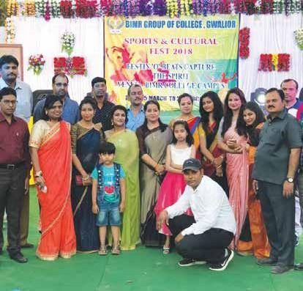

30

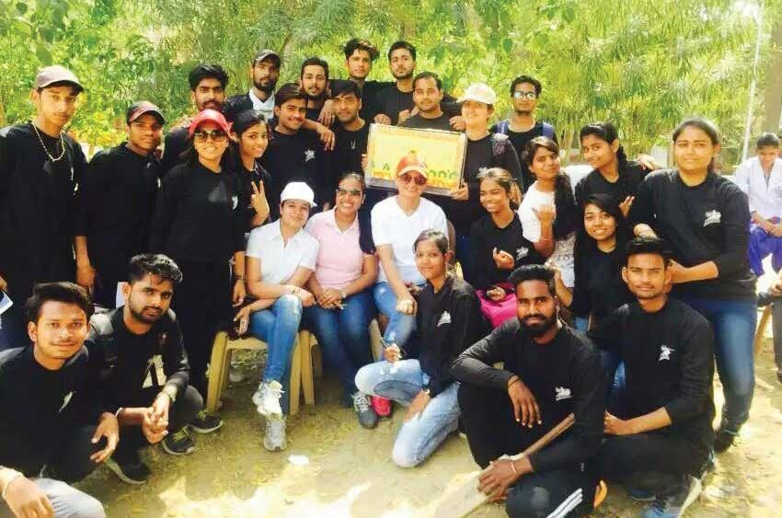
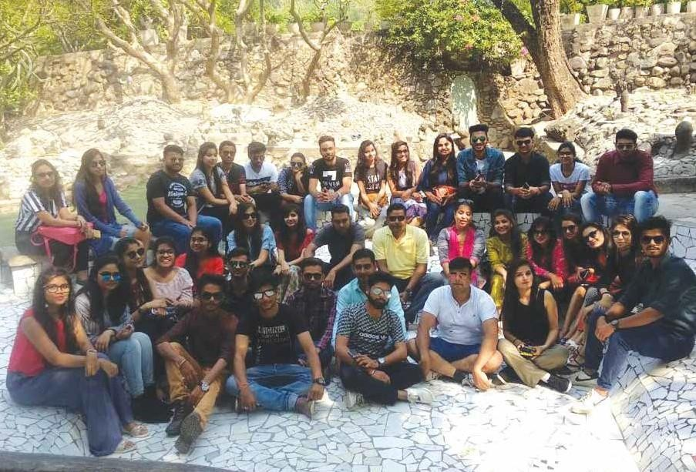

31


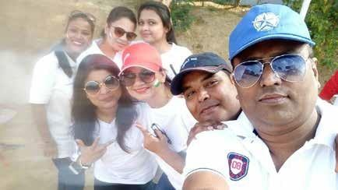
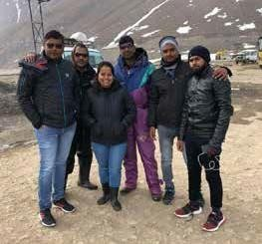

32

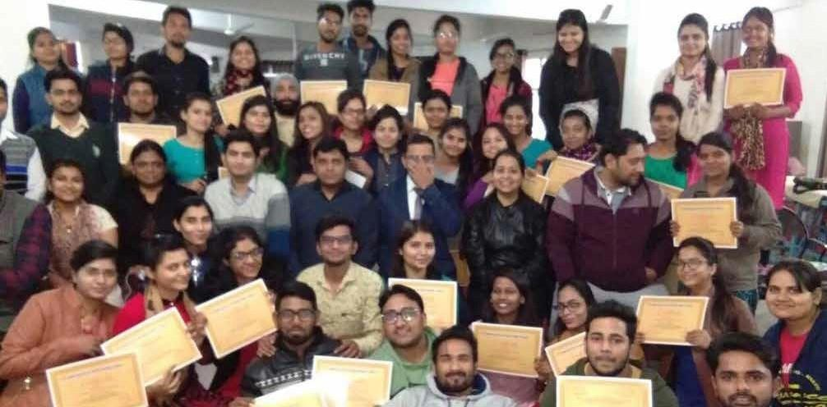
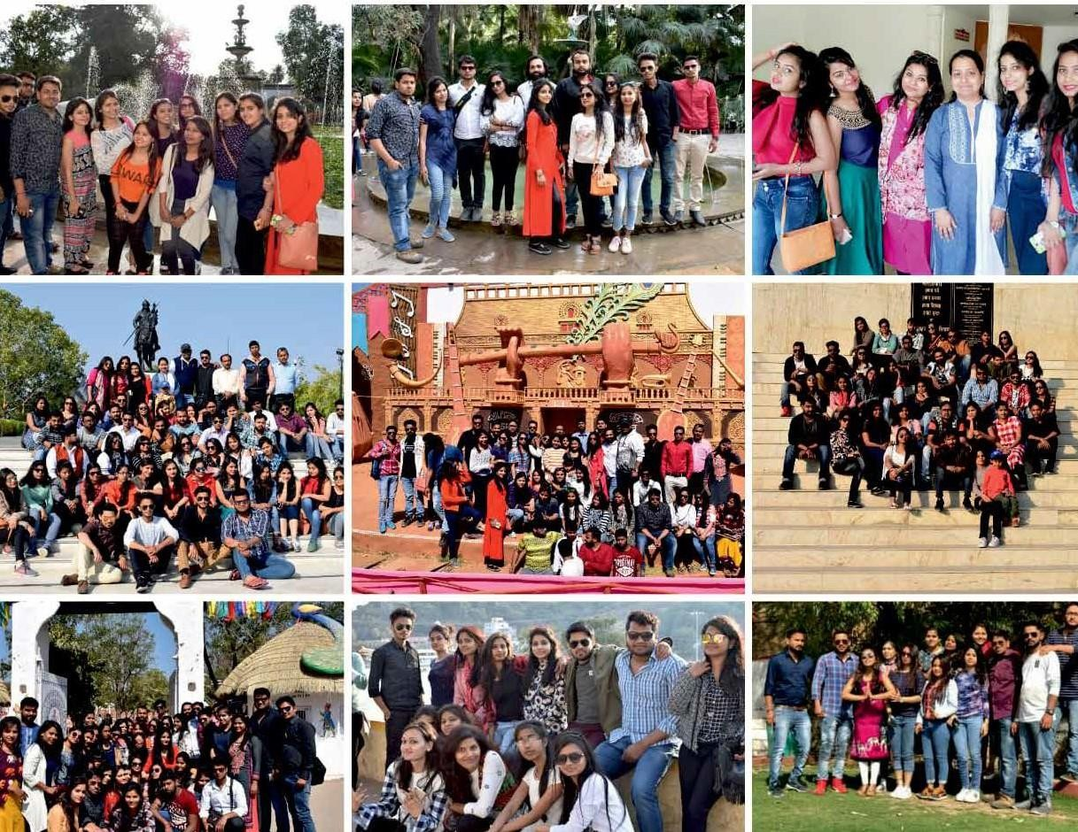

33

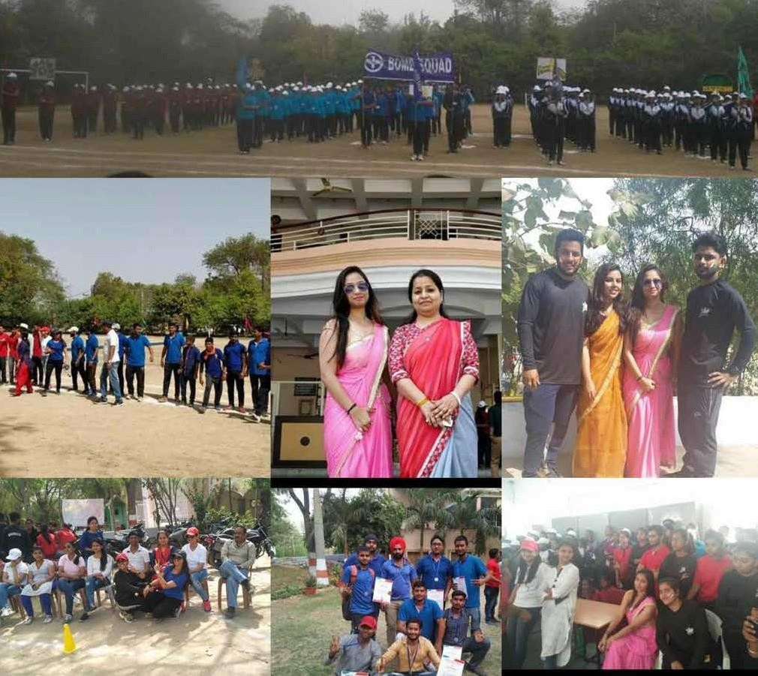
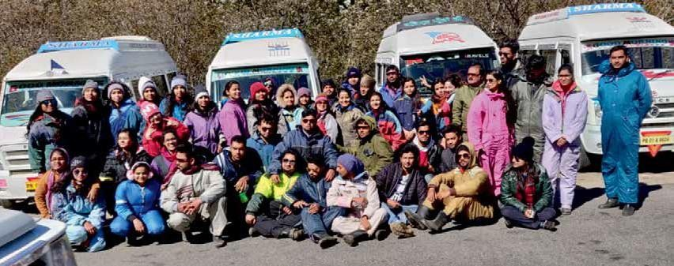

34

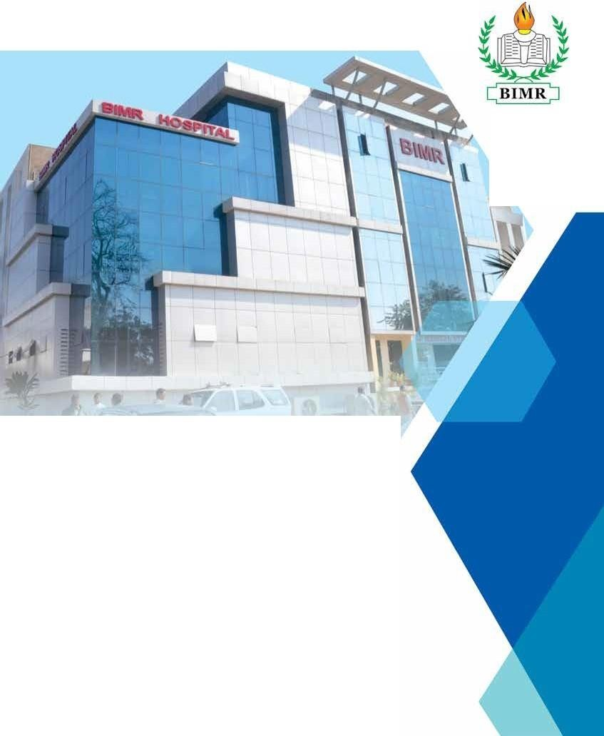

Since 1983

BIMR Hospitals
BIMR Nursing College BIMR Professional College
Surya Mandir Road , Residency, Gwalior (M.P.) 474 005 Phone : 07517102 716, 96307 67700, 07512405 662
E-mail : nurs ingcolleg e@ bimrgwl.com
We bsi te : www.bimr.org

